Introduction to C++

LAB # 01



Spring 2022

CSE-102L COMPUTER PROGRAMMING LAB

Submitted by: MUHAMMAD SADEEQ

Registration No.: 21PWCSE2028

Section: C

"On my honor, as student of University of Engineering and Technology, I have neither given nor received unauthorized assistance on this academic work.'

Student Signature: _____________________

Submitted to:

Engr. Abdullah Hamid

(July 2022)

Department of Computer Systems Engineering University of Engineering and Technology, Peshawar

# Lab 1: Introduction to C++

## Objectives

* To be able to install and use Dev C++ IDE for compiling C++ programs
* To be familiar with syntax and structure of C++ programming

## Topics Discussed in Lab # 1

* Simple C++ Program and a Typical C++ Development Environment
* Test-Driving a C++
* Libraries
* Preprocessor Directives
* Variables and Data Types

## Lab Tasks:

1. Write a program to display your name on console.
2. Write a program to add two numbers (6+3=) and display its sum.
3. Write a program to multiply three numbers (5x5x5=) and display its product.
4. Write a program to find the mod of (5%2=) and (6%2=)
5. Write a program to calculate area of a circle having its radius (ask user to input radius).
6. Write a program to calculate area of an ellipse having its axes (ask user to input values of major, minor)

**COMPUTER PROGRAMMING LAB # 1**

**Answer #1**

**CODE:** 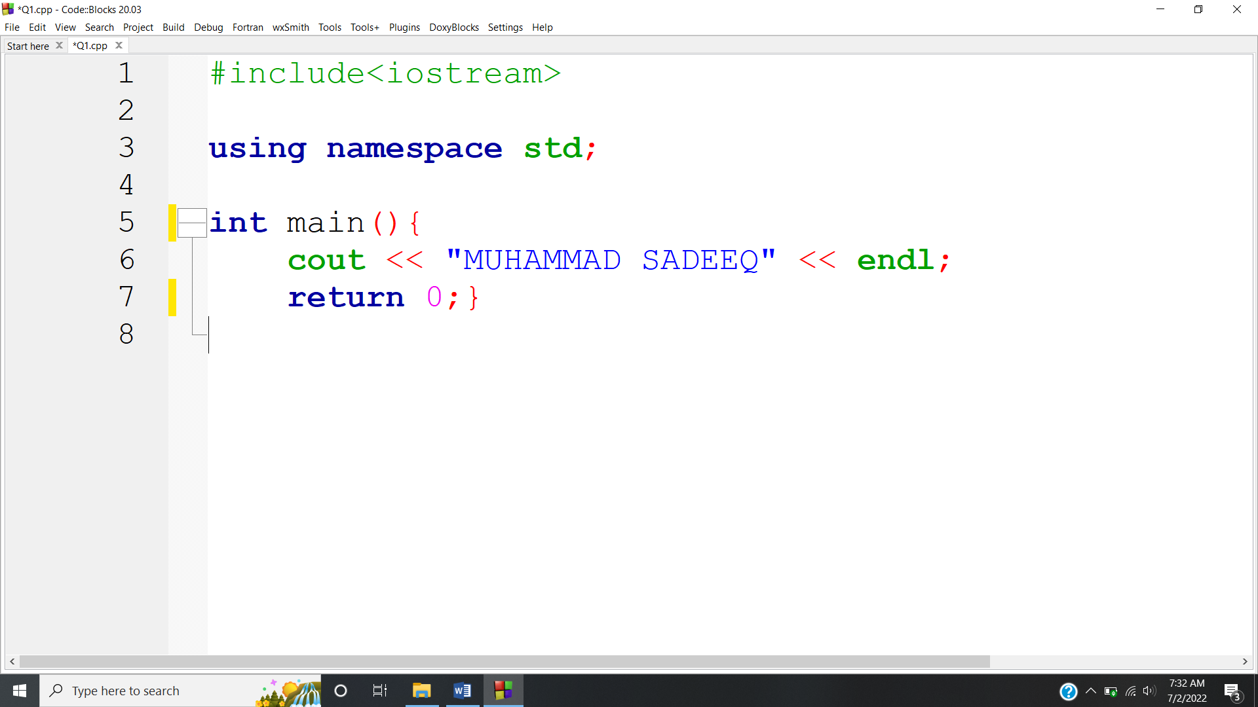

**OUTPUT:** 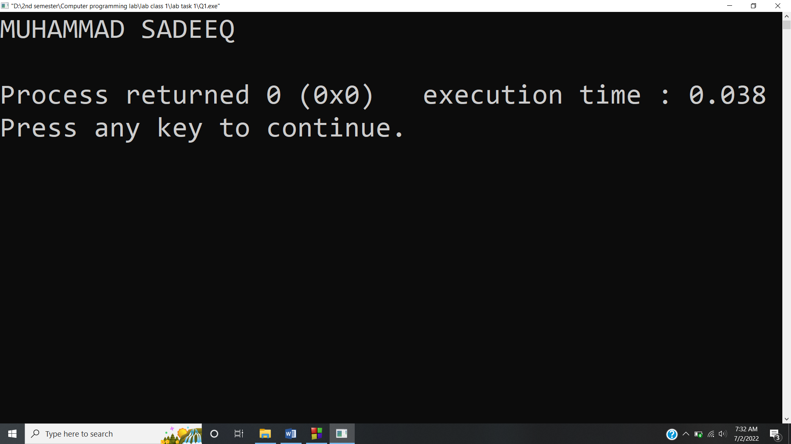

**Answer #2**

**CODE:** 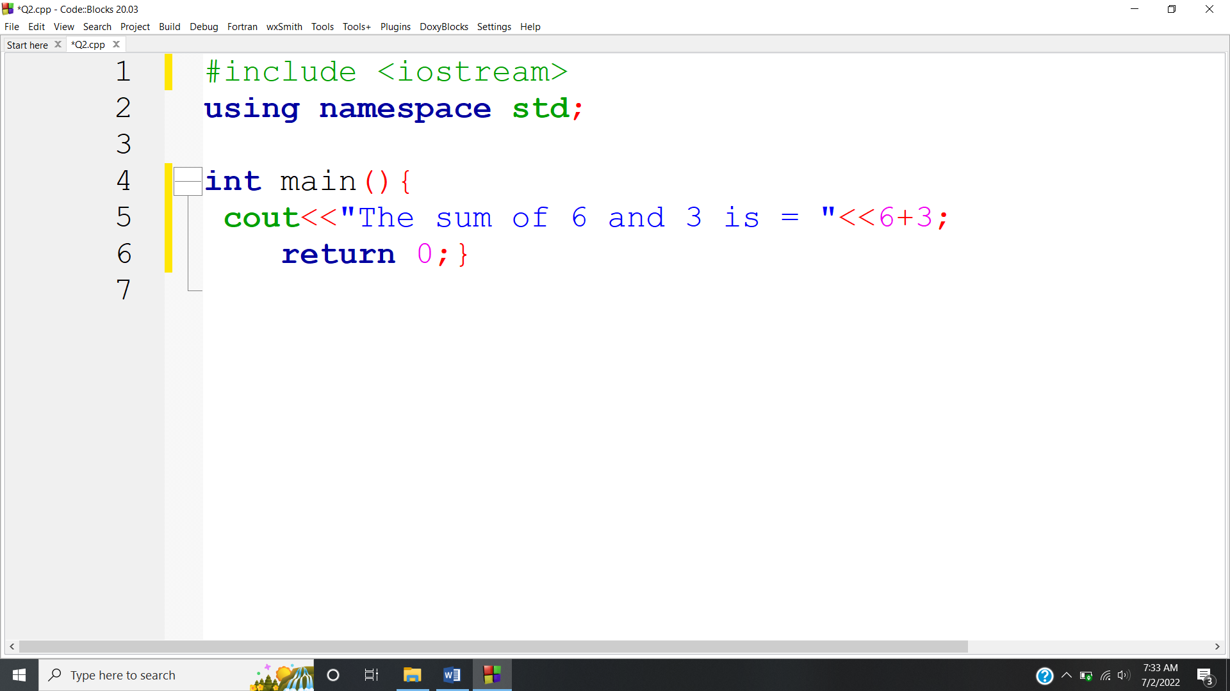

**OUTPUT:** 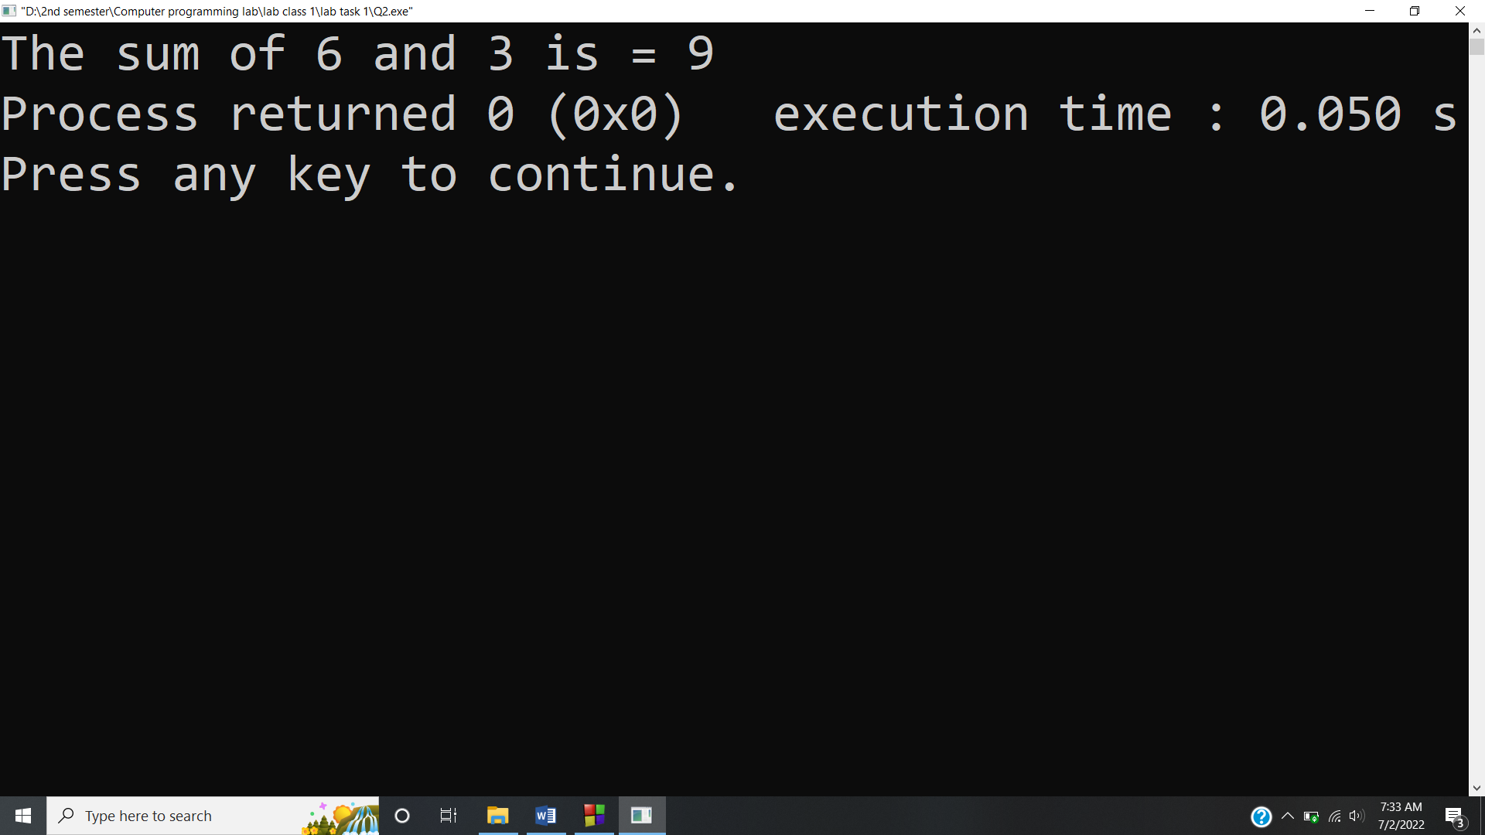

**Answer #3**

**CODE:** 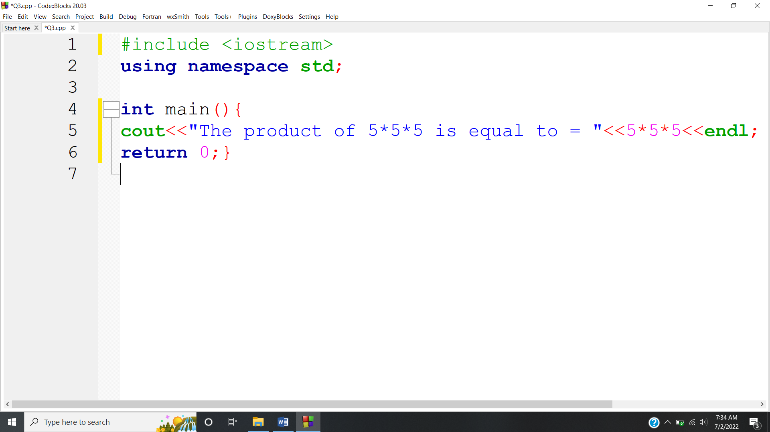

**OUTPUT:** 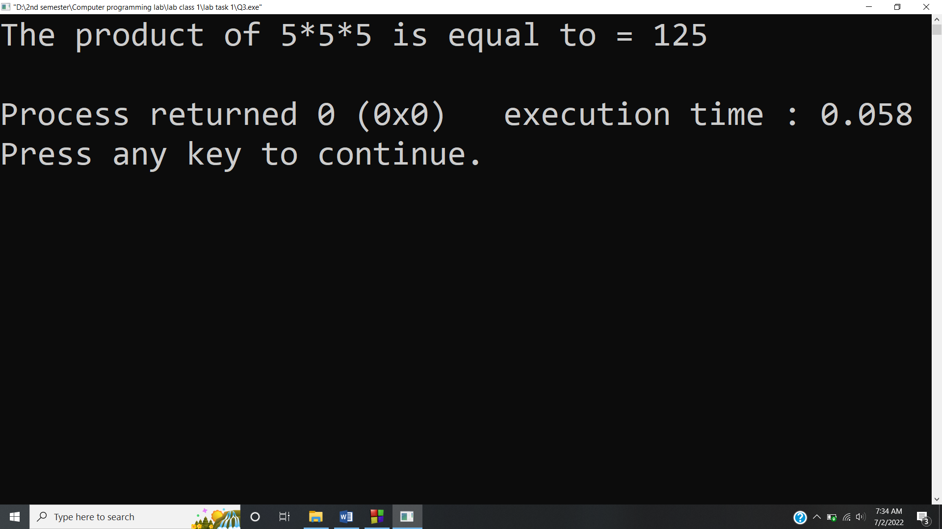

**Answer #4**

**CODE:** 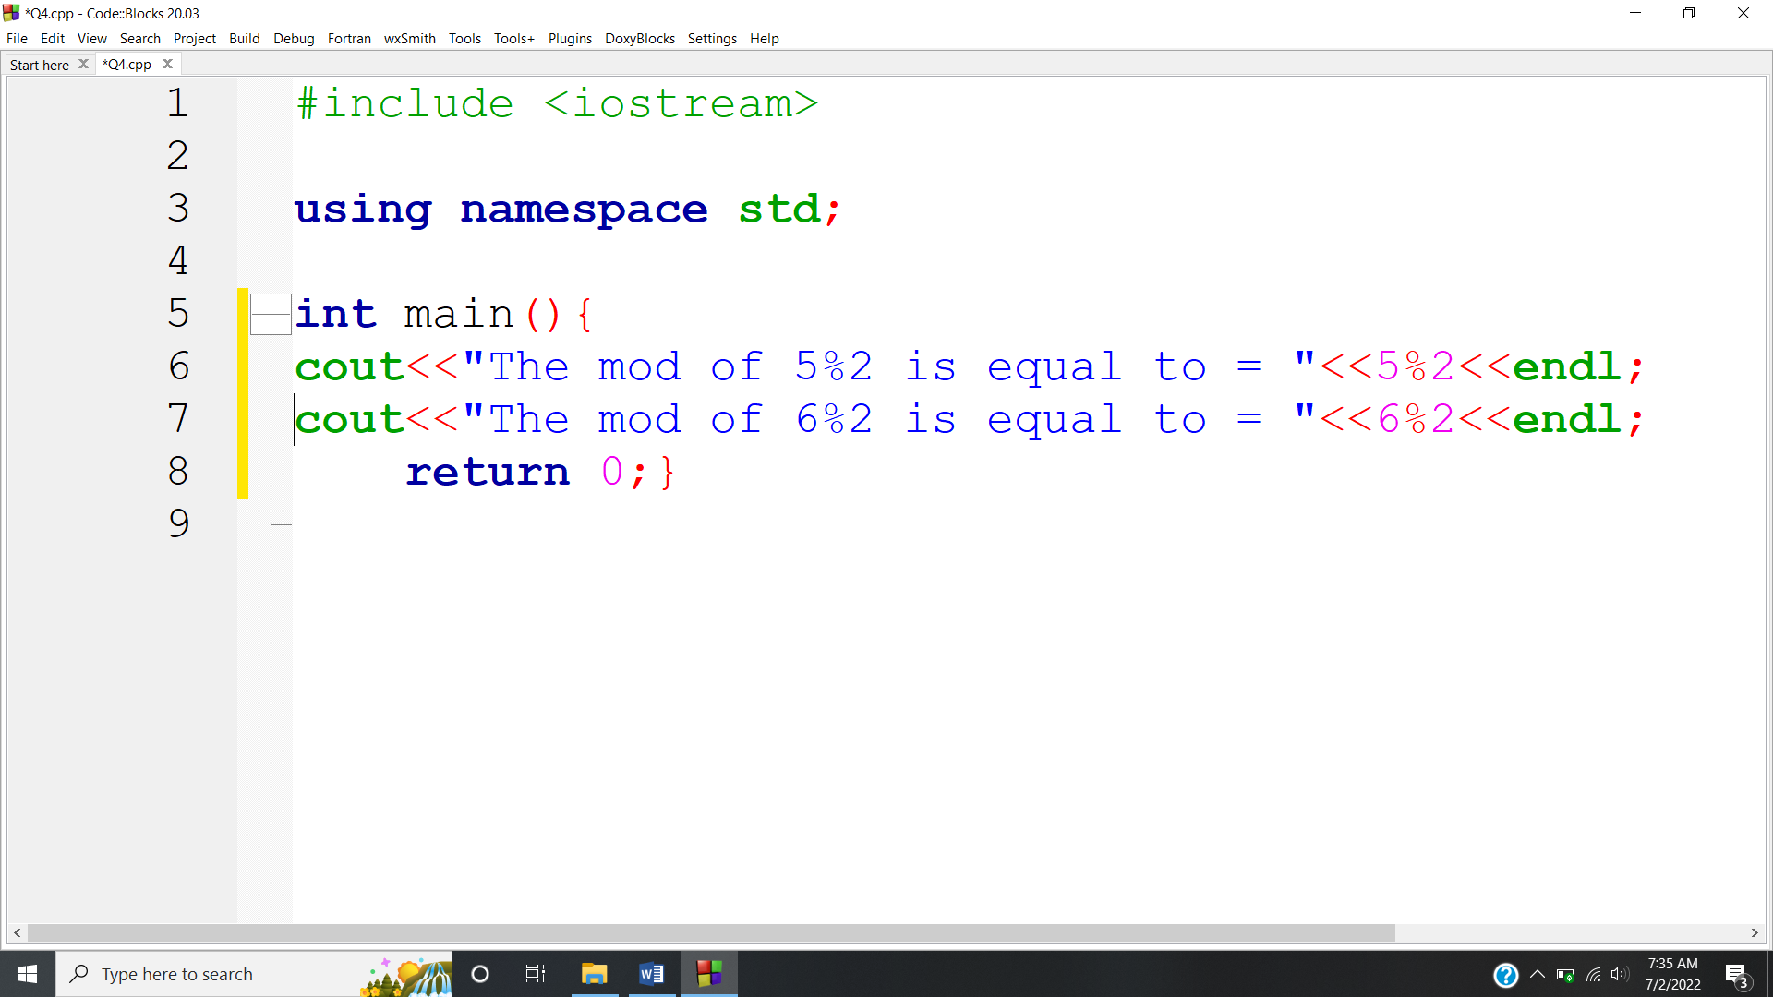

**OUTPUT:** 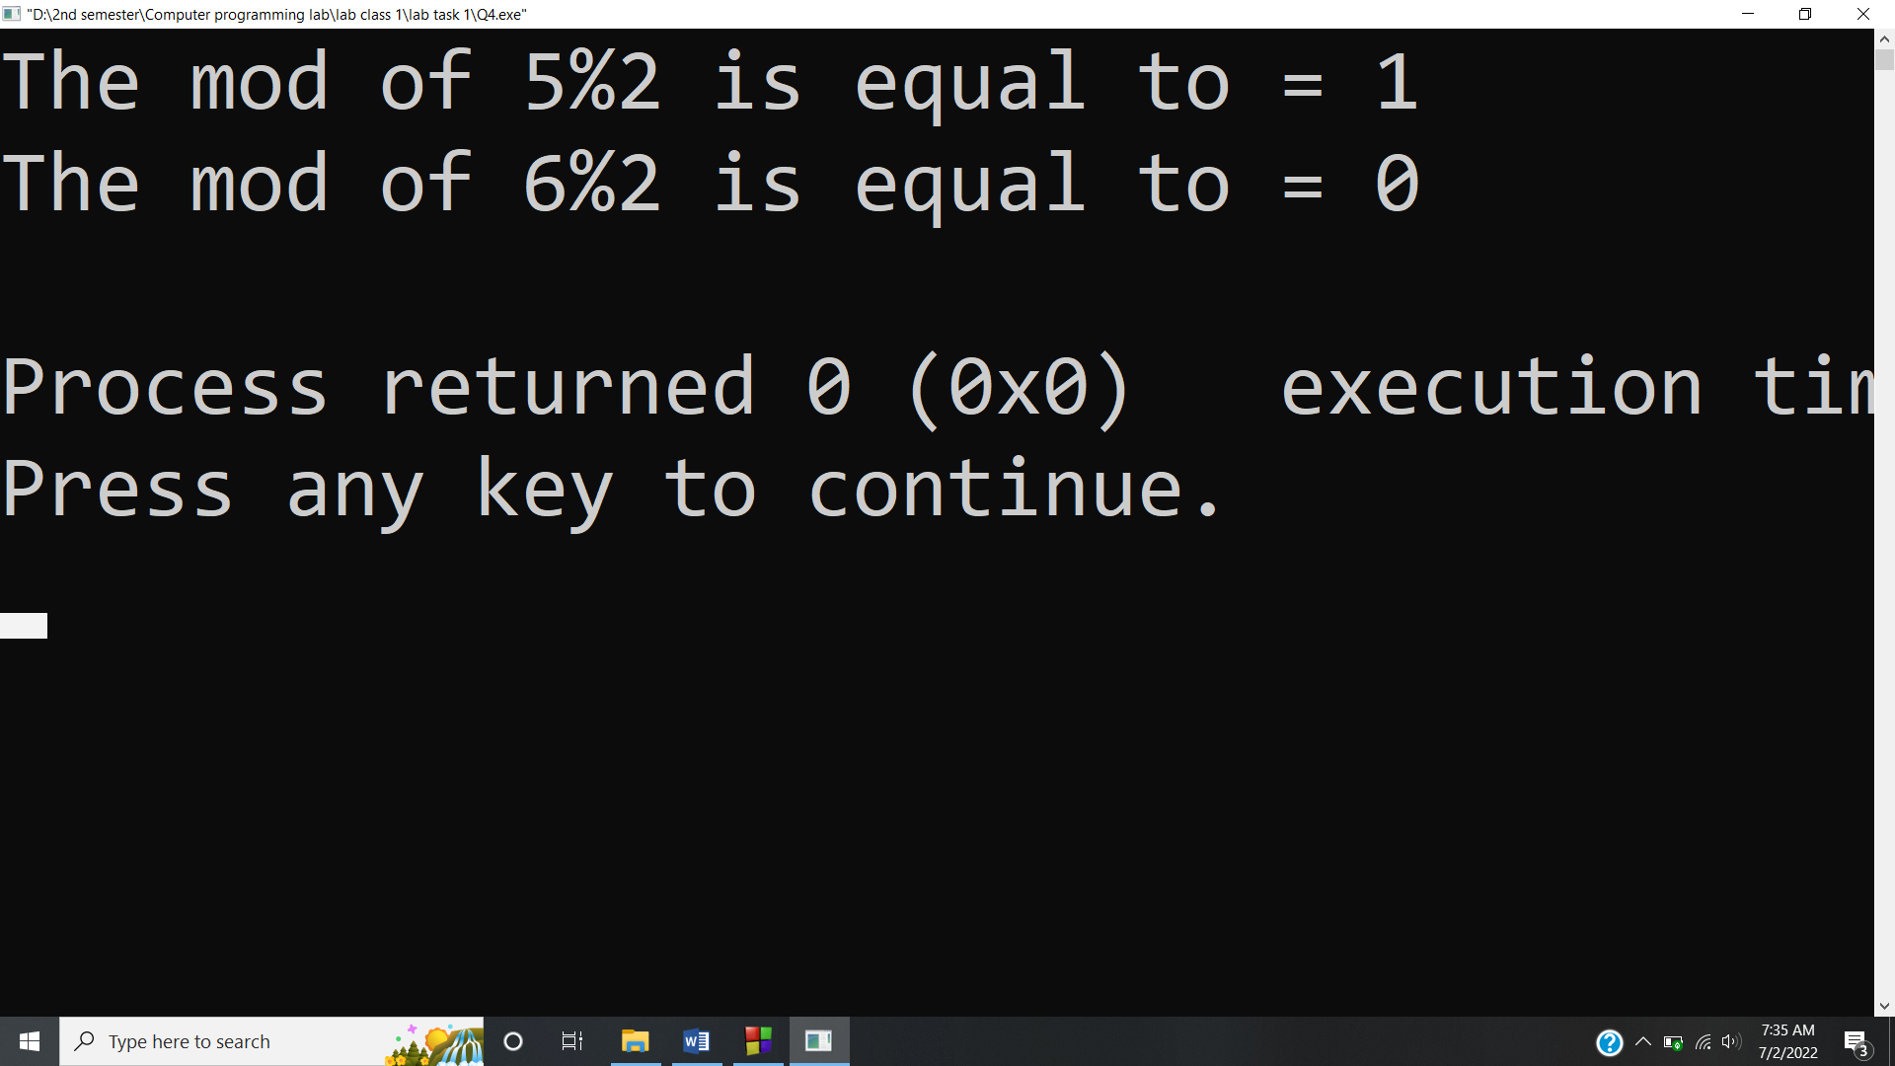

**Answer #5**

**CODE:** 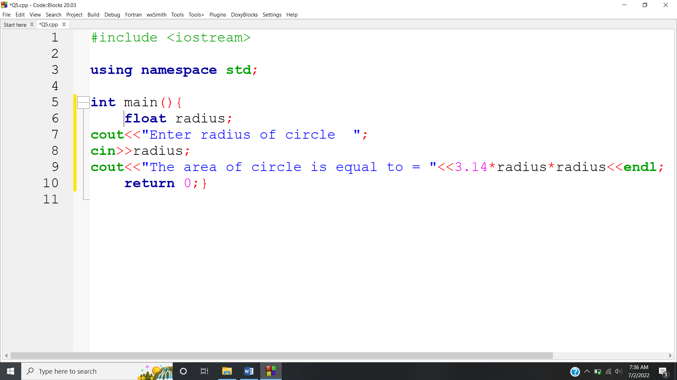

**OUTPUT:** 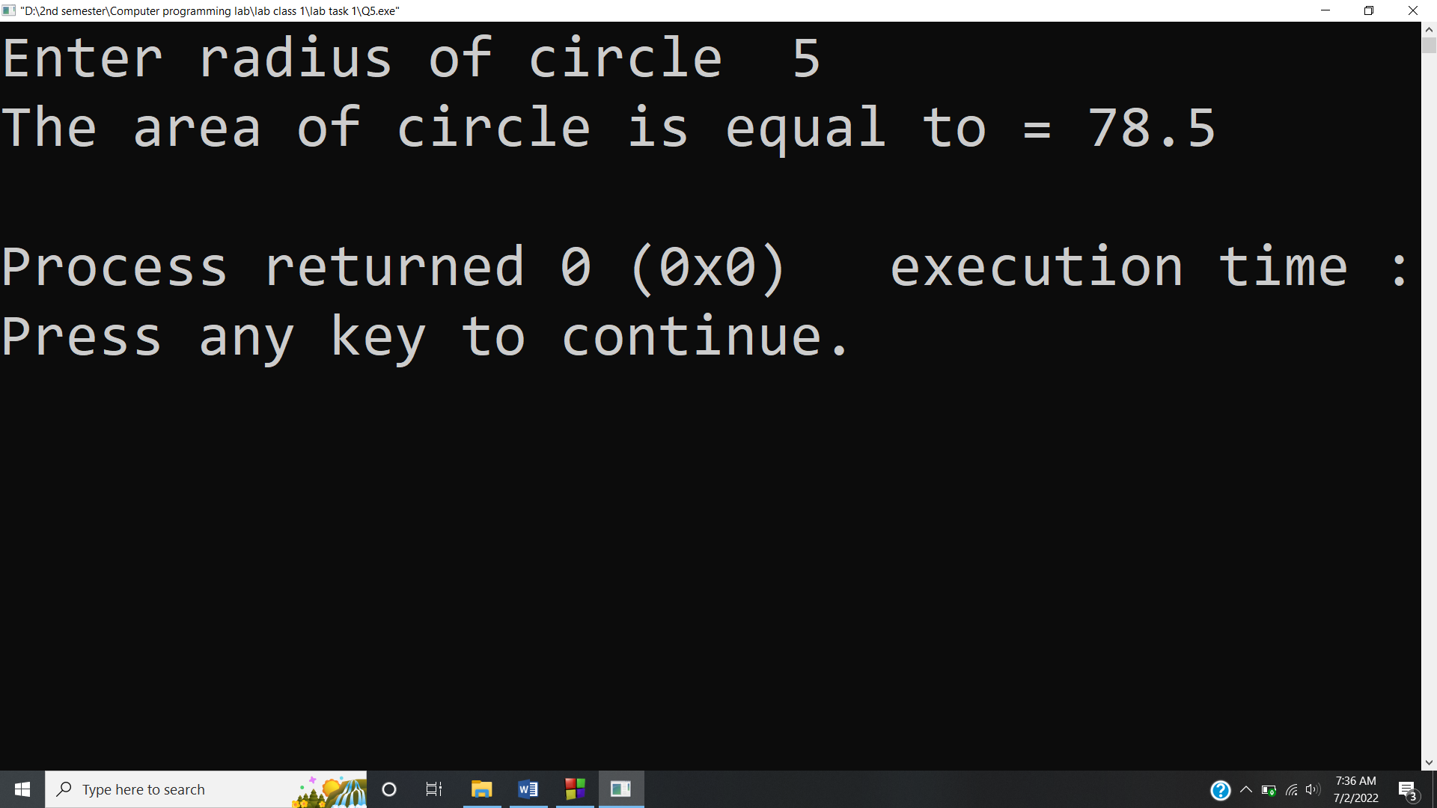

**Answer #6**

**CODE:** 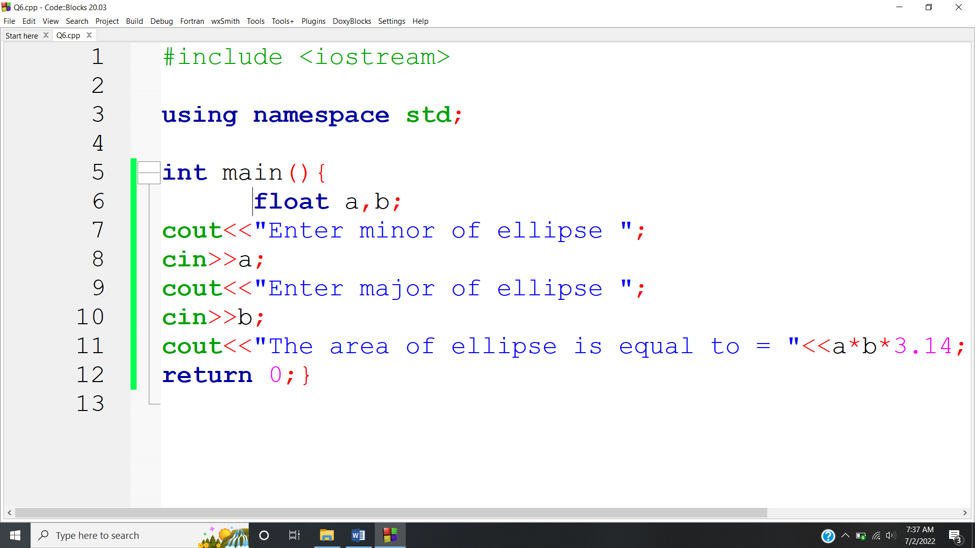

**OUTPUT:** 